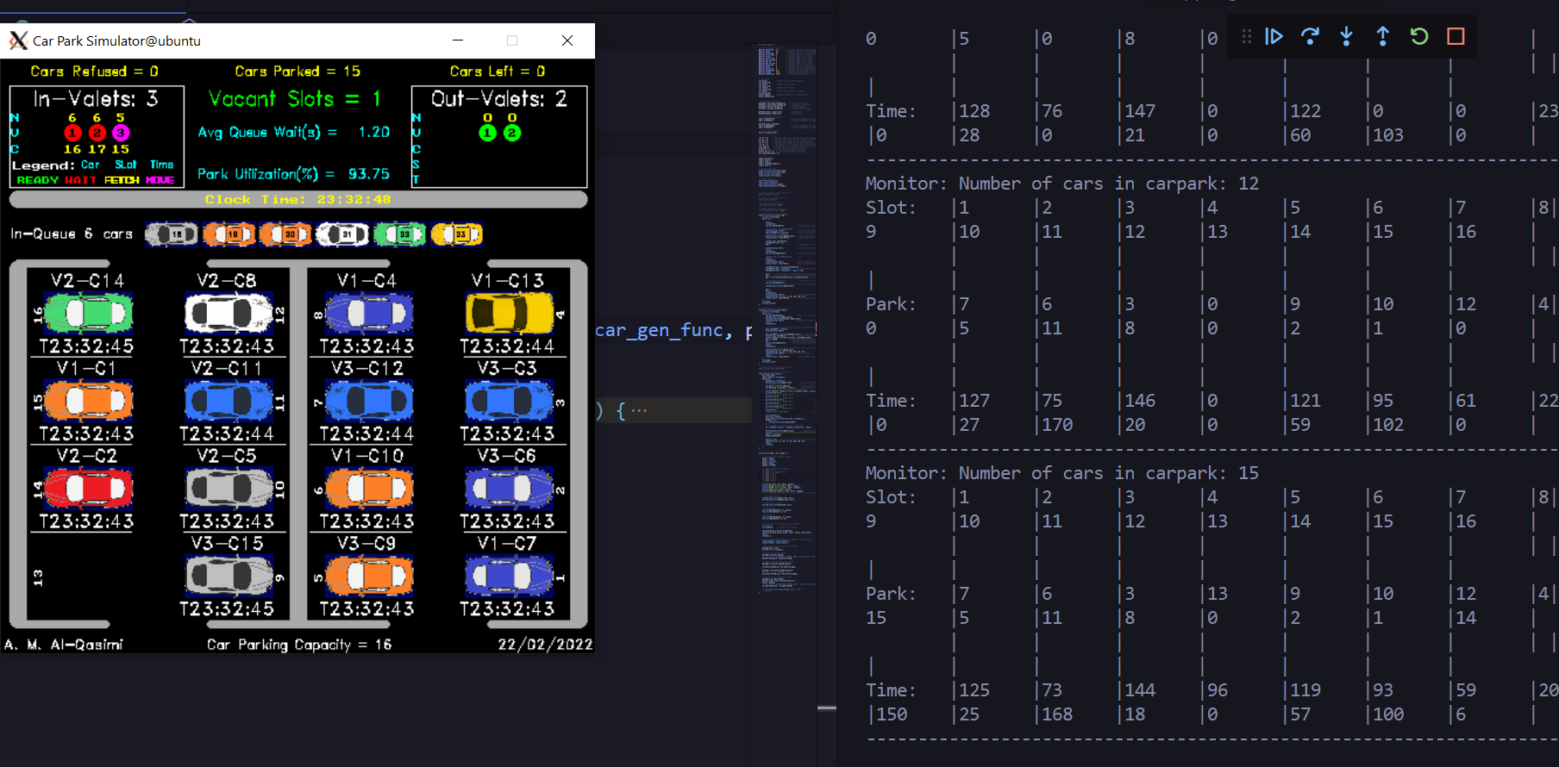

USING DEFAULT ARGS

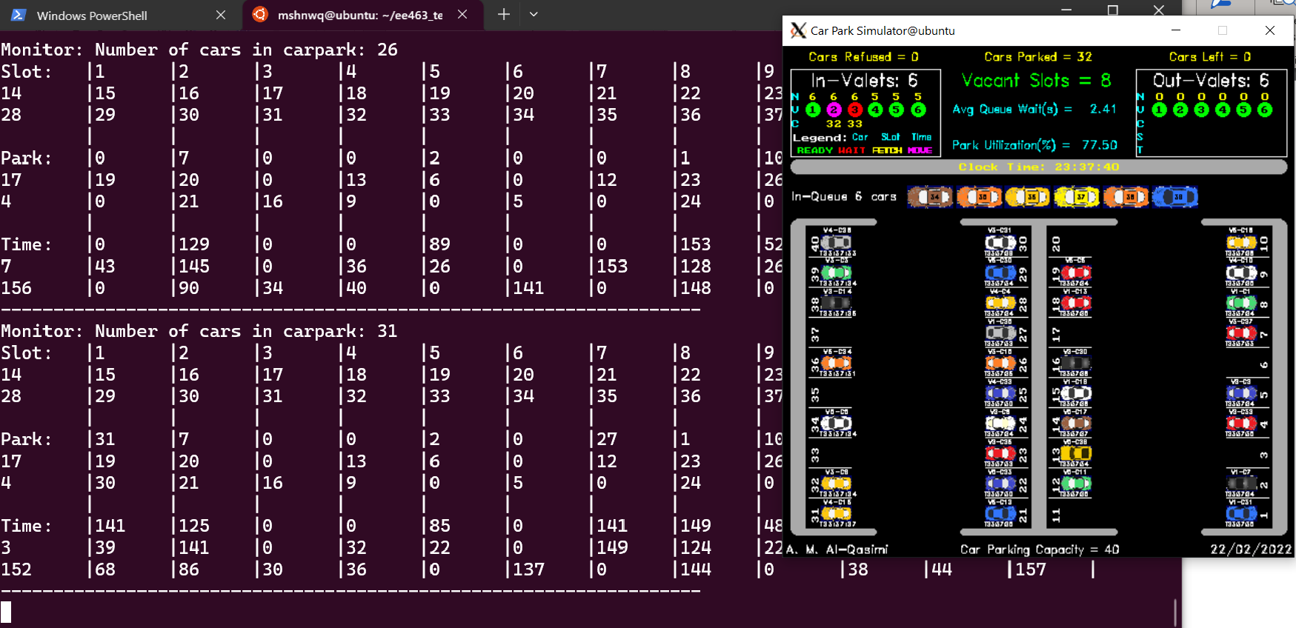Notice that in defaults to the MAX

USING args 50 10 10 10 1

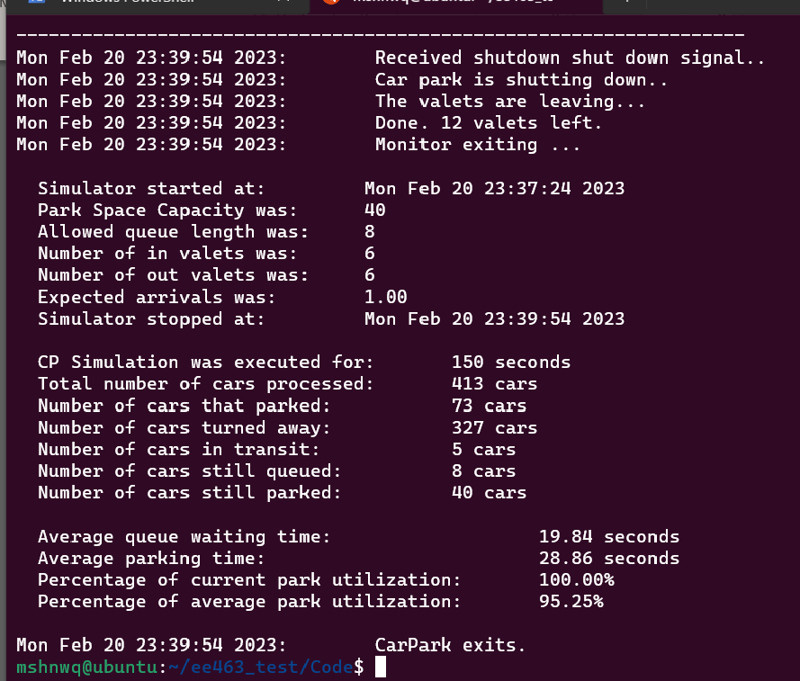

Ctrl^C

USING args 1 1 1 1 0

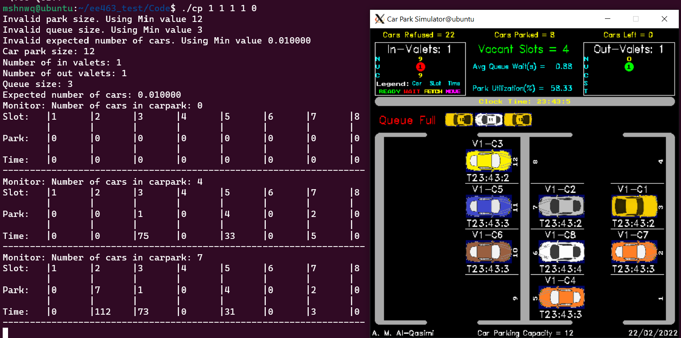Notice that in defaults to the MIN